OPERATING SYSTEMS LAB ENVIRONMENT SETUP
Windows — Ubuntu (WSL), VS Code & Python
s

Assignment

Operating System Lab

Name: Akansha
Roll no: 2401010195
Course: B-Tech CSE Core
Year: 3rd Year, 5th Semester
Roll No: 2401010195 Submitted To: Ms. Suman Punia

1. Objective
The objective is to install, configure and verify the Operating Systems laboratory environment on Windows. The required components are Ubuntu Linux through Windows Subsystem for Linux (WSL), Visual Studio Code and Python. After installation, each component is verified using version/status commands and a basic Python test program.

2. Required Software
- Windows 10/11 with virtualization/WSL support
- Windows Subsystem for Linux (WSL 2)
- Ubuntu Linux distribution
- Visual Studio Code
- Python 3
- Windows Terminal or Command Prompt / PowerShell

3. Step 1 — Check Windows Version
Press Windows + R, type winver, and press Enter. Alternatively, open Command Prompt and run:
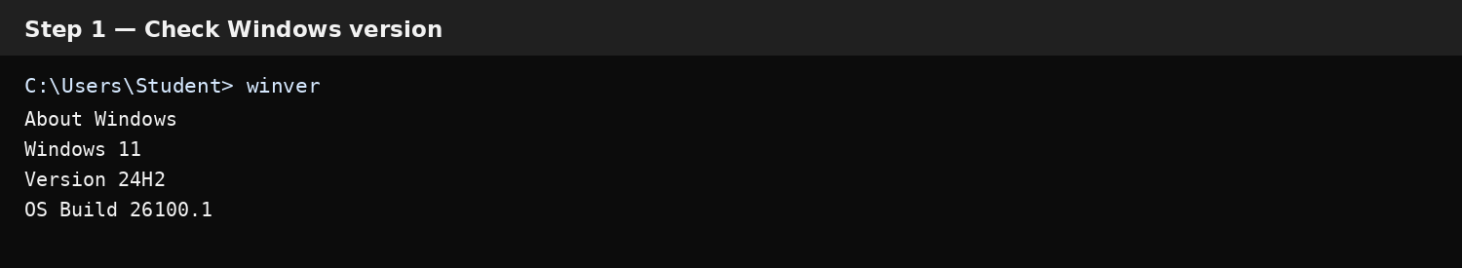
This confirms that Windows 10/11 is installed and shows the current version/build.

4. Step 2 — Install WSL 2
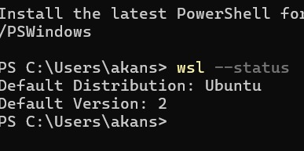

5. Step 3 — Open and Verify Ubuntu
After installation, open Ubuntu from the Start menu. On the first launch, create a Linux username and password when prompted. Then run the following command inside Ubuntu:
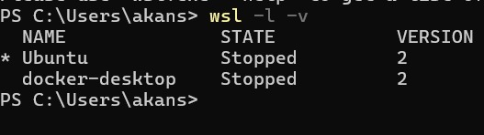

6. Step 4 — Install and Verify Visual Studio Code
Download and install Visual Studio Code for Windows. During installation, enabling the option to add VS Code to the PATH is useful. Open VS Code and install the 'WSL' extension by Microsoft if you want to open Ubuntu/WSL folders directly inside VS Code.
To verify the command-line launcher from Command Prompt or PowerShell, run:
code --version
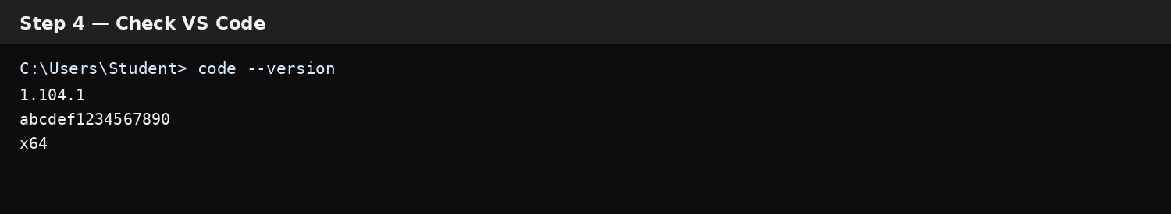

7. Step 5 — Install and Verify Python
Install Python 3 for Windows. During installation, select 'Add python.exe to PATH' if the installer offers that option. Open a new Command Prompt/PowerShell window and run:
python --version
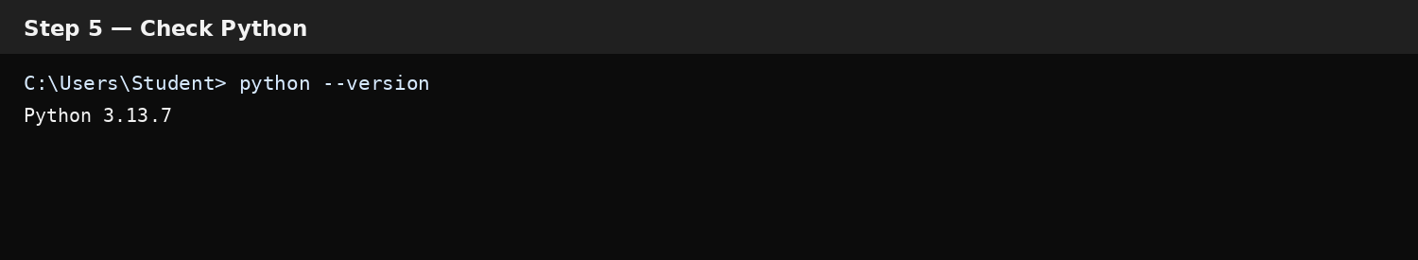

8. Step 6 — Create a Basic Python Test Program
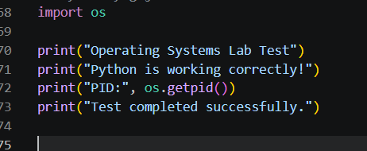
OUTPUT:
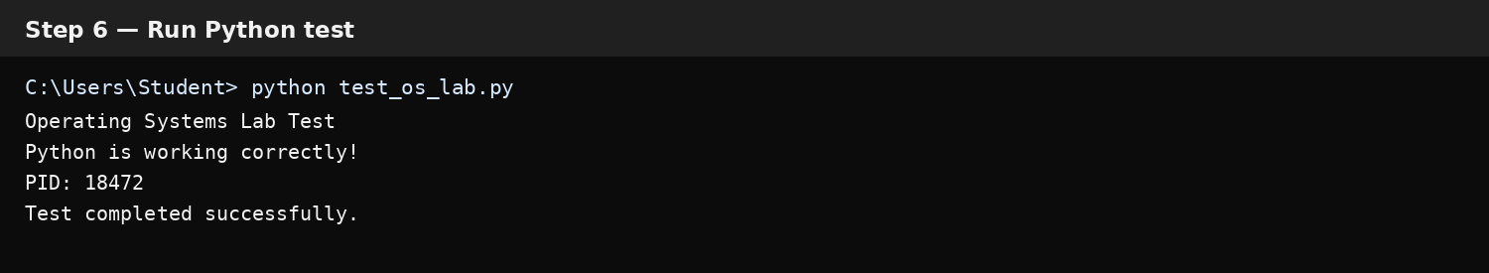
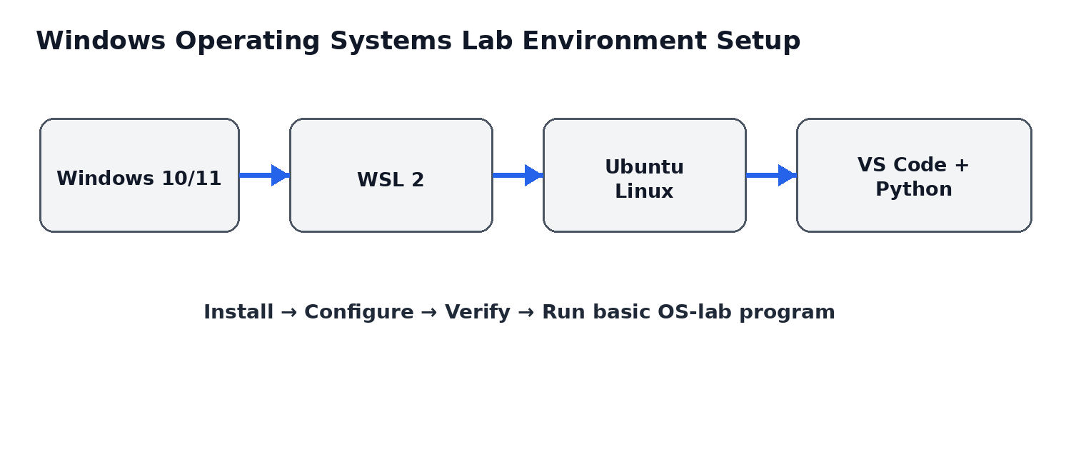10.

Final Result
The Windows Operating Systems lab environment is ready when Windows is verified, WSL 2 is active, Ubuntu opens successfully, VS Code is installed, Python 3 is available, and the basic Python test program runs without errors.

Conclusion
This setup provides a Linux-compatible Operating Systems laboratory environment on Windows using WSL 2. Ubuntu supplies the Linux environment, VS Code provides the development interface, and Python provides the programming runtime needed for Python-based OS lab experiments.

